Instructions on importing eForm into OSCAR:

For video walkthrough of importing eForm to OSCAR, see: https://youtu.be/93XR0XVaKWM

STEPS:

- Download the eForm file
- In your OSCAR EMR system, go to Administration and click Manage eForms
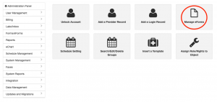
- Click Import
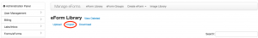
- Click Choose File and select the eForm's .zip file from your computer, then click the new Import button
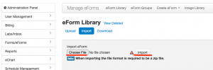
(Your OSCAR may look a bit different but the idea is the same; find the Manage eForms option and import the file. Make sure to click the Import option and not "Upload"!)

How to use the eForm in OSCAR:

There are 2 ways to use eForms you have imported into OSCAR…

HOW TO CREATE EFORM FROM PATIENT CHART:

- From patient’s eChart, select the “+” next to eForms (don’t confuse this with Forms!):
- The “Add eForm” screen will appear. From the list of eForms, click on the eForm you want to create:
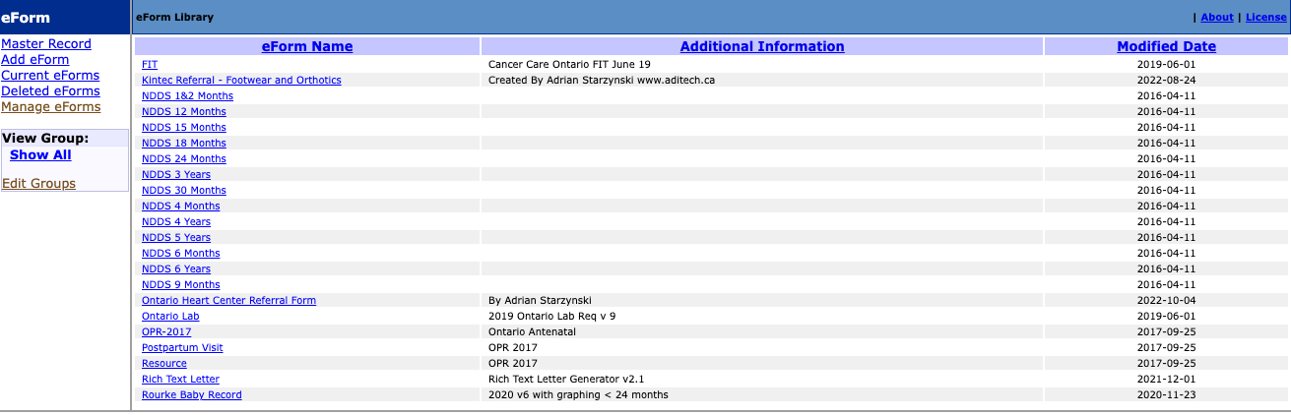

HOW TO CREATE EFORM FROM PATIENT’S MASTER DEMOGRAPHIC RECORD:
- From patient’s demographic record, click “Add eForm”:
Your screen may look something like this, but just click the “Add eForm” option:
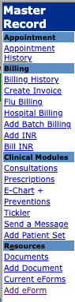
- The “Add eForm” screen will appear. From the list of eForms, click on the eForm you want to create:

